**Question 1: Do AgNPs have an effect on yellow perch N, P, C and Tag excretion?**

**Question 2: How does Tag release vary with time?**

**Answer 1: AgNPs increase N excretion, decrease DOC excretion, and have no effect on P excretion.**

**Answer 2: Tag release also decreases with time from first year of AgNPs addition**

# Anova: Log TDN excretion in 2015 ~ Lake

* Excluding 2014 because of low sample sizes for both lakes; yet may be a difference between 2014/2015

summary(aov.Nnx)

Df Sum Sq Mean Sq F value Pr(>F)

Lake 1 8.087 8.087 9.158 0.00601 **

Residuals 23 20.311 0.883

---

Signif. codes: 0 ‘***’ 0.001 ‘**’ 0.01 ‘*’ 0.05 ‘.’ 0.1 ‘ ’ 1

25 observations deleted due to missingness

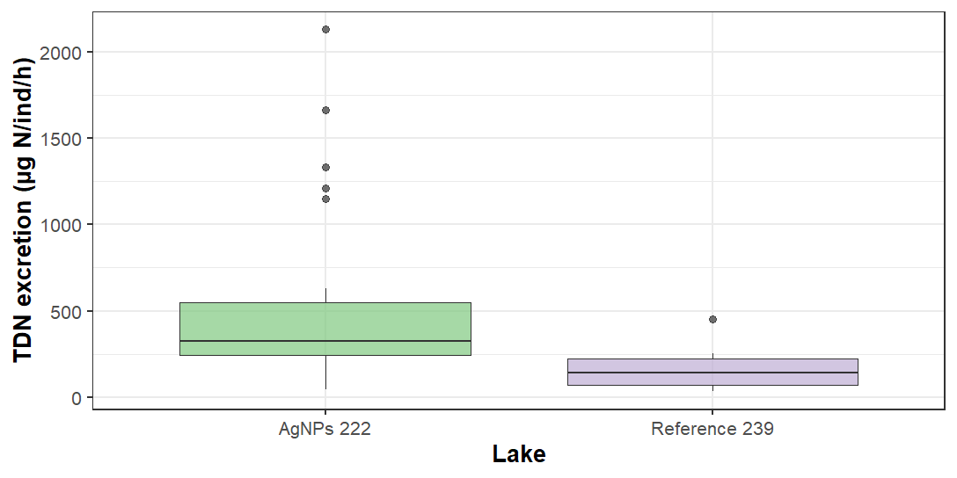

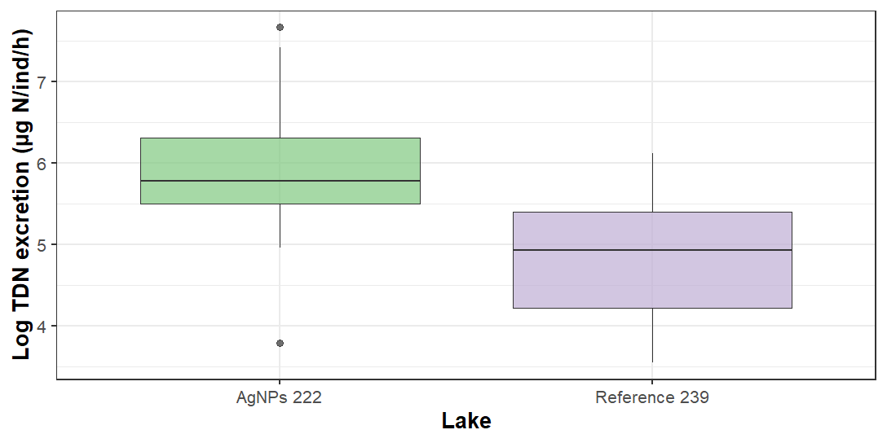

# Anova: Log TDN excretion in 2012, 2015 ~ Lake*Year

> summary(aov.Nx)

Df Sum Sq Mean Sq F value Pr(>F)

Lake 1 14.73 14.726 14.368 0.00037 ***

Year 1 23.61 23.605 23.032 1.22e-05 ***

Lake:Year 1 1.54 1.541 1.504 0.22519

Residuals 56 57.39 1.025

---

Signif. codes: 0 ‘***’ 0.001 ‘**’ 0.01 ‘*’ 0.05 ‘.’ 0.1 ‘ ’ 1

40 observations deleted due to missingness

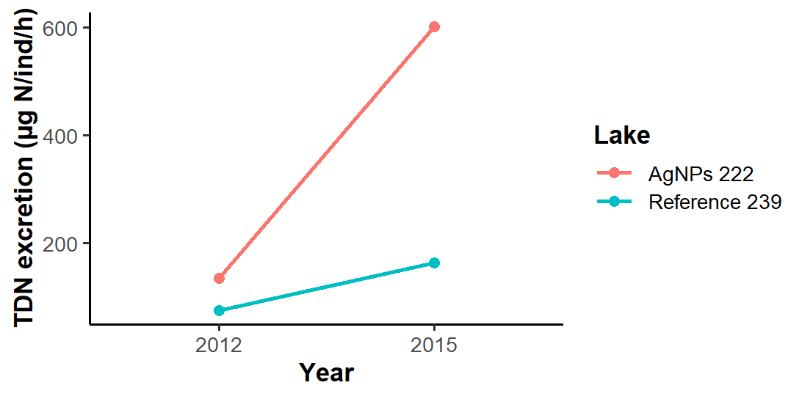

# Anova: TDP excretion ~ Lake

summary(aov.Pnx)

Df Sum Sq Mean Sq F value Pr(>F)

Lake 1 0.5 0.501 0.019 0.892

Residuals 76 2048.0 26.948

22 observations deleted due to missingness

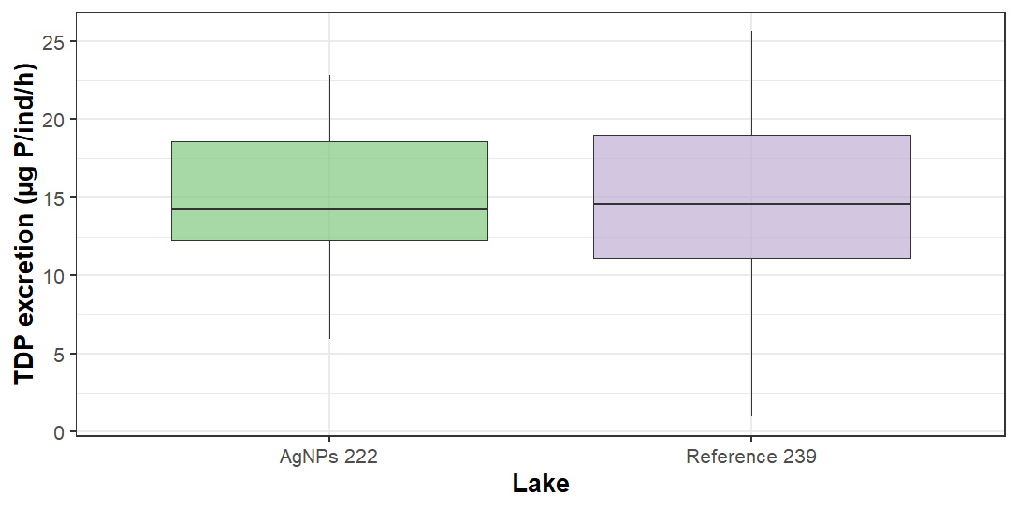

# Anova: Log TDP excretion in 2012, 2014, 2015 ~ Lake*Year

> summary(aov.Px)

Df Sum Sq Mean Sq F value Pr(>F)

Lake 1 1.698 1.6983 7.124 0.00875 **

Year 2 0.091 0.0455 0.191 0.82636

Lake:Year 2 5.954 2.9771 12.488 1.28e-05 ***

Residuals 111 26.462 0.2384

---

Signif. codes: 0 ‘***’ 0.001 ‘**’ 0.01 ‘*’ 0.05 ‘.’ 0.1 ‘ ’ 1

33 observations deleted due to missingness

> TukeyHSD(aov.Px, conf.level=0.95, which = 'Lake:Year')

Tukey multiple comparisons of means

95% family-wise confidence level

Fit: aov(formula = Log.P.excretion ~ Lake * Year, data = NPexcr)

$`Lake:Year`

diff lwr upr p adj

239:2012-222:2012 0.87065510 0.417019991 1.324290219 0.0000027

222:2014-222:2012 0.39519268 -0.058442436 0.848827792 0.1253372

239:2014-222:2012 0.41798614 -0.035648974 0.871621254 0.0891534

222:2015-222:2012 0.44286543 -0.004916087 0.890646938 0.0543826

239:2015-222:2012 0.27903753 -0.168743983 0.726819042 0.4653963

222:2014-239:2012 -0.47546243 -0.934876565 -0.016048289 0.0380140

239:2014-239:2012 -0.45266896 -0.912083102 0.006745174 0.0559330

222:2015-239:2012 -0.42778968 -0.881424793 0.025845435 0.0764578

239:2015-239:2012 -0.59161758 -1.045252689 -0.137982461 0.0033635

239:2014-222:2014 0.02279346 -0.436620676 0.482207601 0.9999912

222:2015-222:2014 0.04767275 -0.405962366 0.501307862 0.9996392

239:2015-222:2014 -0.11615515 -0.569790262 0.337479966 0.9760902

222:2015-239:2014 0.02487929 -0.428755828 0.478514399 0.9999855

239:2015-239:2014 -0.13894861 -0.592583725 0.314686503 0.9485917

239:2015-222:2015 -0.16382790 -0.611609409 0.283953616 0.8956187

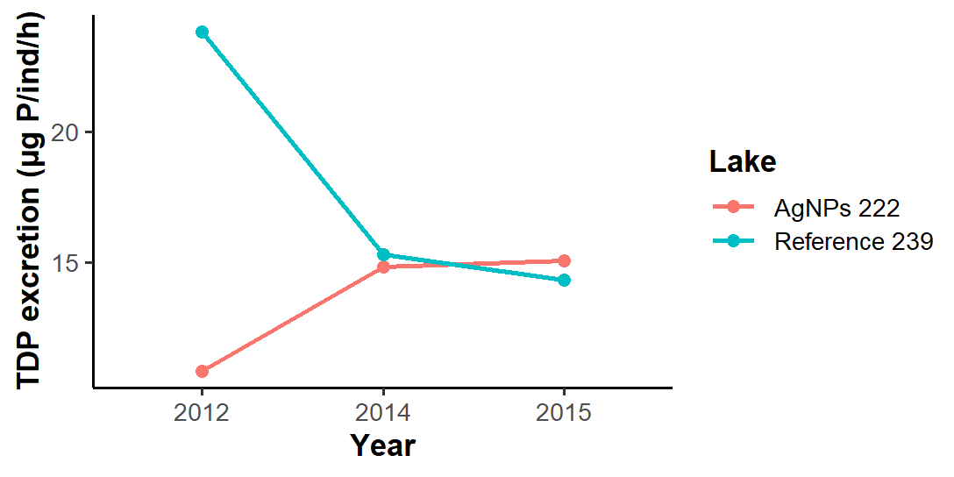

# Anova: DOC excretion ~ Lake

summary(aov.C)

Df Sum Sq Mean Sq F value Pr(>F)

Lake 1 0.2811 0.28111 4.41 0.0493 *

Residuals 19 1.2112 0.06375

---

Signif. codes: 0 ‘***’ 0.001 ‘**’ 0.01 ‘*’ 0.05 ‘.’ 0.1 ‘ ’ 1

79 observations deleted due to missingness

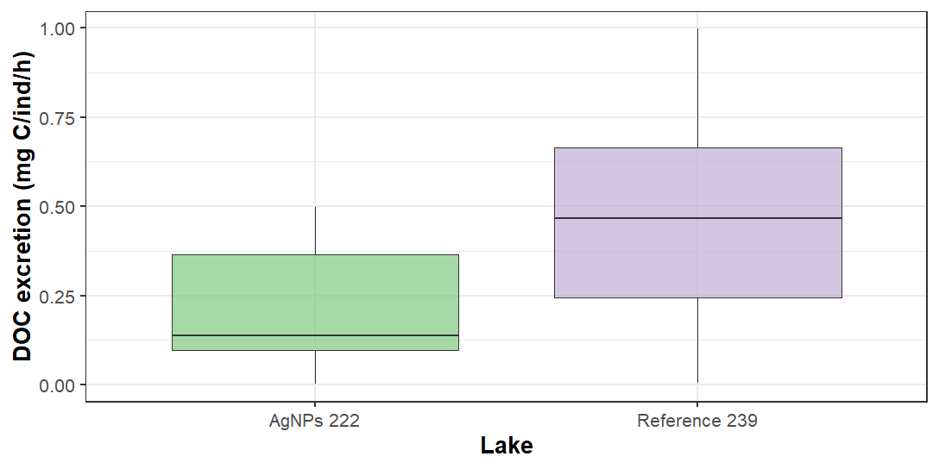

*Note: very low DOC excretion for both lakes*

# Excreted N:P ~ Lake

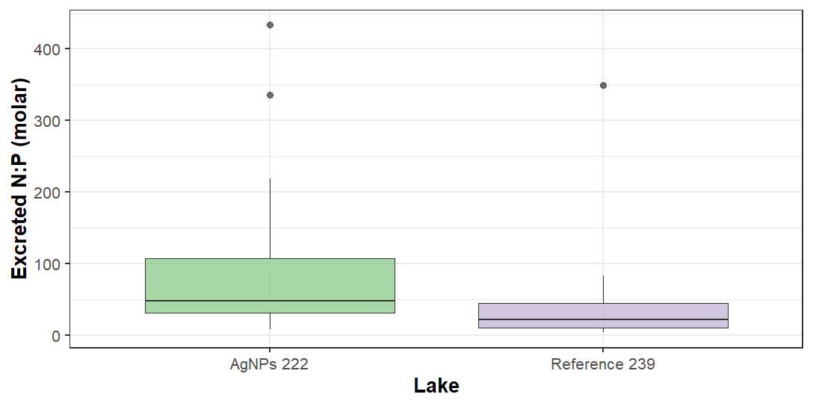

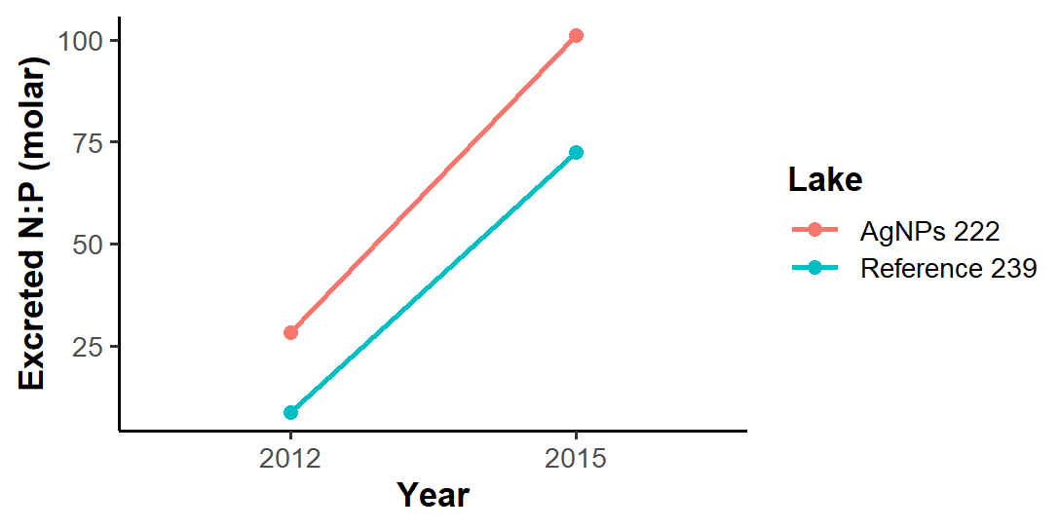

# Excreted C:N ~ Lake

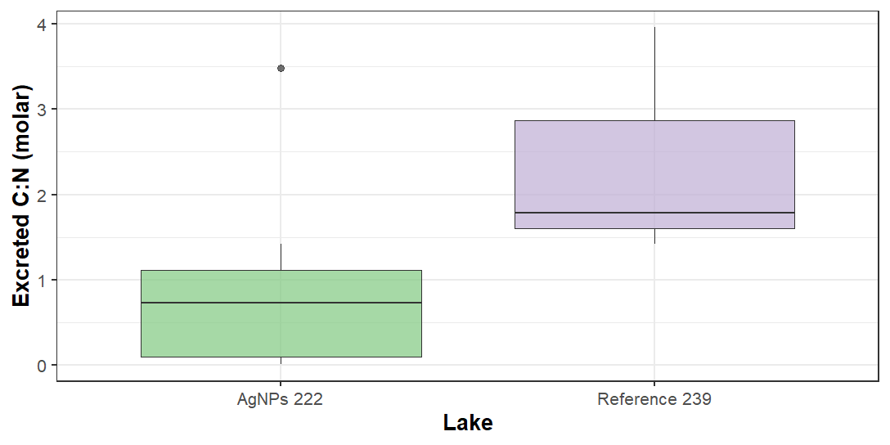

*Note: very low DOC excretion for both lakes + no time series because only have DOC data in 2015*

# Anova: Log Tag excretion ~ Year

summary(aov.Tag)

Df Sum Sq Mean Sq F value Pr(>F)

Year 1 5.48 5.480 13.5 0.00077 ***

Residuals 36 14.61 0.406

---

Signif. codes: 0 ‘***’ 0.001 ‘**’ 0.01 ‘*’ 0.05 ‘.’ 0.1 ‘ ’ 1

62 observations deleted due to missingness

